Laserfiche ID Shield Integration Specifications

{Possibility} = Points for which there is an implementation choice to be made or that requires more investigation.

Definitions:
Unprocessed- A document that has not been scheduled for processing, processed, verifying, verified or failed processing via ID Shield.
Pending processing- A document scheduled for redaction via the background redaction service.
Processing- A document that is currently being auto-redacted via the background service or is a document currently queued for on-demand redaction.
Processed- A document that has been auto-redacted by ID Shield.
Pending Verification- A document scheduled for manual review to verify all sensitive data has been redacted.
Verifying- A document that is currently being displayed for verification.
Verified- A document for which redactions have been manually corrected or verified. These documents will usually, but need not necessarily have been, processed.
Failed- A document for which ID Shield encountered an error when attempting to process a file.

- Laserfiche Tags
  - Laserfiche tags will be utilized by ID Shield to track documents through the redaction process and identify the location of ID Shield settings. The ID Shield Administration Console will have the ability to add these tags to the database.
    - ID Shield – Settings: This tag indicates the Laserfiche folder which contains ID Shield settings information. This tag should be applied to one Laserfiche folder only.
    - ID Shield – Needs Processing: Applied to documents scheduled for processing by ID Shield. It is not valid for this tag to be used in conjunction with any other ID Shield tag.
    - ID Shield – Processed: Applied to documents that have been processed by ID Shield (but not necessarily verified). This tag should never be applied to a document that is tagged “ID Shield – Pending Processing”.
    - ID Shield – Needs Verification: Applied to documents scheduled for manual verification of redactions. This tag should never be applied to a document in the pending processing, processing or verified state.
    - ID Shield – Verified: Applied to documents for which redactions have been manually corrected and/or verified. This tag should never be applied to a document in the pending processing, processing or pending verification states.
    - ID Shield – Failed Processing: Applied to documents for which processing was attempted, but failed. This tag should never applied be to a document tagged “ID Shield – Processed”.

- ID Shield Settings Folder
  - One folder per repository configured to work with ID Shield will be tagged “ID Shield – Settings”. Any ID Shield product connecting to the repository will use this folder to access/update ID Shield settings for the repository.
  - When connecting to a repository, ID Shield will locate the folder in the repository with this tag. After locating the tag for the first time on a machine, location of the folder will be cached to the registry and simply verified each time the location is needed. If the verification attempt indicates that the location of the folder as stored in the registry is no longer valid, ID Shield will search for the folder and update the registry cache appropriately.
  - The folder will contain the following a file named “IDShield.ini”: This file stores all settings available in the ID Shield Administration Console.
  - IDShield.ini format:
    - “[Redaction]” section
      - “MasterRSD” A variable specifies the path to the rules file to be used for redaction
      - “DataToRedact” A comma delimited list of attribute types to redact (ie, “HCData, MCData”)
    - “[Verification] section
      - “AutoTag”
0 = Do not automatically tag documents redacted as pending verification.
1 = Automatically tag documents redacted as pending verification.
      - “TagAll”
0 = If AutoTag is on, apply pending verification tag only to documents that in which HCData, MCData, LCData or Clues were found.
1 = If AutoTag is on, apply pending verification to all tag to all documents regardless of whether sensitive data was found.
      - “OnDemand”
0 = Even if AutoTag is turned on, do not launch verification automatically following On-Demand redaction.
1 = If AutoTag is turned on and at least one document was tagged pending verification, launch verification automatically once on-demand redaction is complete

- ID Shield Administration Console
  - The ID Shield Administration Console will be launched separately (not via the Laserfiche Client).
  - Settings will be shared for all ID Shield products interacting with a repository. The settings will be maintained by the ID Shield Administration Console and stored in a designated repository folder.
  - When opened, a login prompt will be presented requiring the repository, user name and password. (Figure 1). If the user needs to specify a specific server name, they can do so by entering the server and repository name in the format “[server]/[repository]” rather than selecting from the list of automatically discovered repositories.
  - Once the login button is pressed, Repository Connection Checks (below) will be performed to confirm login credentials, and user rights and privileges. If the login credentials are wrong or the user does not have appropriate rights and privileges, a message will be displayed to that effect and the login prompt will be re-displayed after the message is OK’d. (Figure 2). Exceptions dealing with the ID Shield tags or ID Shield directory will not be directly displayed, but will be reflected in how the console’s controls are initialized.
  - Settings can be modified via the Administration Console from any machine with access to the repository.
  - Only one machine can be running the ID Shield Administration Console at once. This is enforced by locking the repository’s IDShield.ini file while the console is open.
  - Available settings:
    - Repository Tab (Figure 3)
      - “Create Tags” button—The button will add the required tags to the Laserfiche repository. This button will be disabled once all necessary tags are added to the database.
      - “About Tags” button— The button will display a window describing the tags ID Shield will add and use to track documents in the redaction process. (Figure 4)
      - ID Shield Settings folder path edit box— (read-only) This box will display one of the following:
        - “ID Shield – Settings tag not yet created” prior to “Add Tags” button being pressed.
        - “ID Shield – Settings tag not found” if the tag is available in the repository, but no folder is found with that tag
        - The path name of the single Laserfiche folder tagged as ID Shield – Settings
        - “Error- multiple folders have been tagged ‘ID Shield – Settings’” If more than one folder is found with the tag
      - “Refresh” button— This button re-checks the availability of the ID Shield tags and the location of the folder tagged ID Shield – Settings.
      - “Change” button— Prompts user for a new Laserfiche folder to tag as ID Shield settings. (Figure 5). If the newly selected folder does not contain an existing IDShield.ini file:
        - If the previously configured location exists in the repository and contains an IDShield.ini file, it will be copied to the new directory
        - If the previously configured location does not exist in the repository or does not contain an IDShield.ini file, a new file will be created with default settings.
      - “Un-tag all pending documents that are not processing” button— Removes “ID Shield – Pending Processing” tag from all documents that are not processing.
      - “Tag all processed documents as verified” button-- adds “ID Shield –Verified” tag to all documents tagged “ID Shield – Processed”.
    - Redaction Settings Tab (Figure 6)
      - Rule selection edit box- Specifies the location of the ID Shield rules file to use for auto-redaction processing. The rules are external to the ID Shield repository and should therefore be referenced by a full UNC path so it can be accessed from all machines.
      - Redaction sensitivity checkboxes- Specifies which types of sensitive data found should be redacted. (high, medium or low confidence data)
      - Verification checkbox- Specifies whether processed documents should be automatically tagged for verification (pending verification). Documents can be scheduled in one of two ways:
        - “Tag all documents” radio button- All documents processed should be scheduled for verification even if no sensitive data or clues are found in the document.
        - “Tag only documents with sensitive data” radio button- Only documents in which high, medium or low confidence data or clues are found are tagged for verification (regardless of which types of data is configured to be redacted)
      - “Automatically initiate verification” checkbox causes the processed documents to be automatically brought up for verification according to the specified method of tagging documents for verification. This checkbox is disabled if the primary verification checkbox is not selected.
  - If any change has been made in the settings, the user will be prompted upon pressing OK/Apply: “Warning: All active ID Shield sessions (both background processing and on-demand processing) must be stopped before applying the new settings. Ensure all ID Shield sessions are stopped before continuing.” After the message is OK’d, prompt the user “Have all ID Shield sessions been stopped?”
    - If yes, save the settings to the IDShield.ini file.
    - If no, the OK/Apply operation is cancelled.

- On-Demand Processing
  - On-demand processing is initiated via the “Process with ID Shield” button in the Laserfiche Client (Figure 10).
  - On-demand processing will immediately auto-redact the currently selected set of documents.
    - Document selection methods:
      - Individual selection of one or more documents in Laserfiche using [ctrl]-[click], [shift]-[click], [ctrl-a] or any other selection methods. This can be done via either the folder view or the search results view.
      - Selection of one or more documents folders. ID Shield will recursively redact all document below the selected folder(s).
  - The processing will be performed with the open user session being used by the Laserfiche Client. The Laserfiche Client must remain open while redaction is in progress.
  - On-Demand redaction process
    - Repository Connection Checks (below) are performed ensure the repository is properly prepared, the current user has appropriate rights and privileges, etc. If any of the checks fail, and appropriate error message is presented (Figure 11).
    - The list of selected files is loaded into memory, while displaying “Collecting Documents…” prompt modal to the Laserfiche Client window (Figure 12). For each document in the selection set:
      - If the current user does not have the necessary permissions to process the document, a count of such documents is incremented and the document is removed from the selection set.
      - If the document is locked, a count of locked documents is incremented, and the document is removed from the selection set.
      - If the document is tagged “ID Shield – Processed”, the a count of already processed documents is incremented and a shortcut to the document is added to the “ID Shield – Processing” folder
      - If the document is not covered by any of the preceding conditions, the document is locked for writing.
      - Once all documents have been scanned, as necessary the user will be prompted:
        - “Of [x] selected documents, you do not have necessary permissions to process [y] documents. Do you wish to process the remaining documents?” If no is selected, all documents that were locked for writing are unlocked and the operation ends. If yes, the operation proceeds.
        - “Of [x] selected document(s), [y] are currently locked and cannot be processed. ID Shield may be processing the document(s) on another machine. Do you wish to process the remaining documents?” If no is selected, all documents that were locked for writing are unlocked and the operation ends. If yes, the operation proceeds.
      - If at least one document was tagged “ID Shield – Processed” the user will be prompted “[x] of [y] documents have already been processed. Do you wish to reprocess these documents?” (Figure 13)
        - If yes, documents in the selection set tagged “ID Shield - Processed” are stripped of the tag as well as the “ID Shield – Pending Verification” or “ID Shield – Verified” tags if present.
        - If no, the shortcuts to the documents tagged as “ID Shield – Processed” are unlocked for writing and those documents are discarded from the in-memory list of documents to process.
        - If cancel, all shortcuts that were locked for writing are unlocked and the operation is cancelled.
      - {Possibility} A similar process could be used for documents tagged “ID Shield – Failed”
    - The remaining list of documents are processed (auto-redacted). The user will be presented with a progress box modal to the Laserfiche Client. (Figure 14)
    - For each document that completes processing without error:
      - Remove the “ID Shield – Pending Processing” tag.
      - Apply the “ID Shield – Processed” tag
      - If verification is needed per IDShield.ini settings:
        - Add the document to an in-memory list of documents to be verified.
        - Apply the “ID Shield – Pending Verification” tag
        - Add highlights in the document of clues using a color just a couple of bits different from the normal highlight color.
      - Unlock the document for writing.
    - For each document that fails to complete processing successfully.
      - Remove the “ID Shield – Pending Processing” tag.
      - Remove the shortcut from the “ID Shield – Processing” folder.
      - Apply the “ID Shield – Failed” tag.
      - Unlock the document for writing.
    - If the stop button is pressed while processing a document:
      - Unlock all remaining documents that were locked for processing.
      - {Possibility}After processing has stopped, if more than one document was processed and tagged for pending verification, display a prompt asking whether the user wants to verify those redactions (is it implied “do not verify in the pressing of the stop button”?)
        - If yes, proceed with verification.
        - If no, the operation is over-- do not begin verification process.
    - After the last document is processed, if more than one document failed to process correctly, display a message indicating the number of documents that failed processing.
  - Perform verification of all successfully processed documents assuming at least one document completed processing and the user did not request to stop without verifying. (See Verification section below)

- Background Processing
  - All background processing will occur via a Windows service named “ID Shield Background Processing for Laserfiche”
    - The service is configured via the ID Shield Background Processing Service Configuration program (Figure 7)
      - For each machine running the service, the configuration console must be provided login credentials for a repository that has been prepared for ID Shield (contains the necessary tags and has and available ID Shield settings folder)
      - The repository drop down will display a list of available Laserfiche repositories.
      - The user and password fields specify which Laserfiche user the background service will use to process documents.
      - The “Threads for Processing” controls allow the user to specify how many threads the redaction service should use to process documents.
        - “Use as many threads as needed to achieve peak performance” will use one thread per core available on the machine
        - Use [x] threads uses [x] threads for processing regardless of how many cores are available.
      - “Start” button—upon entering the required credentials and pressing start, the Repository Connection Checks (below) will be performed. If any checks fail, a corresponding error message will be presented (Figure 8), otherwise the service will enter the “Running” state (Figure 9).
      - “Stop” button—stops processing any documents currently processing and removes the corresponding shortcuts from the “ID Shield – Processing” folder.
      - “Run background redaction service automatically on startup” checkbox- specifies that the service will start automatically when the computer does. This checkbox is disabled when the service is not started (ie, if the service is stopped via the configuration program, it will not start automatically the next time the computer does even if the box was previously checked).
    - The service itself continuously scans the database for documents tagged “ID Shield – Pending Processing”. Upon finding a document with the tag:
      - A check is made to see that the document is not locked. If it is, the document is skipped.
      - A check is made to see that the Laserfiche user being utilized by the service has appropriate permissions to modify the file. If not, the file is skipped.
      - If none of the preceding conditions apply, the file is processed:
        - The file is locked for writing
        - The file is exported and redactions are calculated by AFEngine and added to the document.
        - The “ID Shield – Pending Processing” tag is removed
        - The “ID Shield – Processed” tag is added
        - If dictated by settings, the document is tagged “ID Shield – Pending Verification” and clue highlights (with custom color) are added to the document.
        - The document is unlocked for writing.
  - Documents will be submitted to the background service via the "Process in background with ID Shield” button in the Laserfiche Client (Figure 10)
    - Upon pressing the submission button, a dialog modal to the Laserfiche Client will be displayed showing the progress of document submission. The dialog initially displays “Collecting documents for background redaction…” (Figure 12)
    - For each document selected:
      - If the current user does not have permission to add tags to the document, a count of such documents is incremented and the document is removed from the selection set.
      - If the document is locked, a count of locked documents is incremented, and the document is removed from the selection set.
      - If the document is tagged “ID Shield – Processed”, the document is locked and the document is added to an in-memory list of processed documents.
      - If the document is not included in any of the previous conditions, it is locked.
      - Once all documents have been scanned, as necessary the user will be prompted:
        - “Of [x] selected documents, you do not have necessary permissions to submit [y] documents for background processing. Do you wish to submit the remaining documents?” If no is selected, all documents that were locked for writing are unlocked and the operation ends. If yes, the operation proceeds.
        - “Of [x] selected document(s), [y] are currently locked and cannot be submitted for background redaction. ID Shield may be processing the document(s) on another machine. Do you wish to process the remaining documents?” If no is selected, all documents that were locked for writing are unlocked and the operation ends. If yes, the operation proceeds.
    - If at least one document was tagged “ID Shield – Processed” the user will be prompted “[x] of [y] documents have already been processed. Do you wish to reprocess these documents?”
      - If yes, the in-memory list of processed documents is discarded.
      - If no, the documents in the list of processed documents are removed from the selection set and are unlocked.
      - If cancel, all documents in the selection set are unlocked and the operation ends.
    - {Possibility}A similar process count be used for documents tagged “ID Shield – Failed”
    - The remaining document set is traversed again with a status message of “Submitting document [x] of [y] for background redaction…” where [y] is the number of the documents remaining in the selection set. (Figure 15). For each document remaining the selection set:
      - If the document is tagged “ID Shield – Processed” (meaning the user chose to re-process processed records):
        - The “ID Shield – Processed” tag is removed
        - If present, the “ID Shield – Pending Verification” tag is removed
        - The “ID Shield – Pending Processing” tag is added
        - The progress dialog’s [x] count is incremented
        - The document is unlocked
      - If the next document is not tagged “ID Shield – Processed”
        - The “ID Shield – Pending Processing” tag is added.
        - If present, the “ID Shield – Verified” and “ID Shield – Failed” tags are removed.
        - The progress dialog’s [x] count is incremented
        - The document is unlocked.
    - Redaction is not necessarily performed on the same machine where redaction was scheduled.
    - Machines need not be running the background service to schedule documents for background redaction.
    - If no machines are running the background service when documents are submitted for background redaction, the documents will remain in the “ID Shield – Pending Processing” state indefinitely.

- Verification
  - Performed on a set of documents hereafter referred to as the “current document set”. The current document set is defined either by the set of documents that successfully completed on-demand redaction and are tagged as “ID Shield – Pending Verification”, or the subset of documents selected in the Laserfiche Client when the Client’s “Verify ID Shield redactions” button (Figure 10) is pressed that are tagged as “ID Shield – Pending Verification”.
  - If verification was launched via the “Verify ID Shield redactions” button rather than as part of on-demand processing, Repository Connection Checks will be executed to ensure proper repository preparation and user rights & privileges.
  - For each document in the current document set:
    - Ensure the document remains tagged as “ID Shield –Pending Verification”. If not, remove the document from the current document set and proceed to the next document in the current document set.
    - Ensure the document is not locked. If it is, remove the document from the current document set and proceed to the next document in the current document set. {Possibility} Prompt user?
    - Lock the document for writing
    - Open the document in Laserfiche and display the floating ID Shield verification toolbar above the Laserfiche document window in z-order. (Figure 16)
      - “Accept Verifications” toolbar button. When pressed:
        - Remove document highlights made with the special clue highlight color.
        - Remove the “ID Shield - Pending Verification” tag
        - Add the “ID Shield – Verified” tag
        - Close the Laserfiche document window.
        - Unlock the document for writing
        - If more pending verification documents remain in the current set of documents, using the next document, repeat the process
        - If no more documents remain, close the ID Shield verification toolbar.
      - “Stop” toolbar button. When pressed:
        - Prompt user to confirm they want to stop the verification process..
        - Close the Laserfiche document window
        - Unlock the document for writing
        - Close the ID Shield verification toolbar
      - “Verifying document” read-only edit box displays the count of documents verified in the current session (including the currently displayed document)
      - “Documents remaining” read-only edit box displays the number of documents remaining in the current document set. NOTE: documents remaining may decrease by more than one document upon verifying a document if the next document in the current document set was verified on another machine or was locked since verification started.

- Repository Connection Checks
  - When ID Shield for Laserfiche products attempt to connect to a database, a series of checks will be made common to all pieces of the ID Shield integration. Failures of these checks will generate exceptions that will be handled differently depending upon which ID Shield component is performing the checks
    - Repository existence: Does the repository exist?
    - Login Credentials: Does the provided Laserfiche username and password successfully establish a connection to the repository?
    - Laserfiche User rights: Depending on the specific ID Shield component (admin console, background service, on-demand redaction, background redaction submission and verification), the Laserfiche user must possess certain rights and privileges or an exception will be thrown.
      - Search (all components)
      - Export (background service, on-demand redaction, verification)
      - {Possibility}Edit Text (may be needed for the background service and on-demand redaction)
      - Process (background service, on-demand redaction)
      - Manage metadata (all components)
    - ID Shield tags. The repository should have all 6 ID Shield tags available (see Laserfiche Tags)
    - ID Shield Settings directory: One and only one directory should be tagged as “ID Shield – Settings”.
      - The “ID Shield – Settings” folder should contain the “IDShield.ini” file and that file needs to load correctly (specified rules file can be found, etc).
      - All components need read access to the settings directory
      - The admin console needs create and modify access as well.

- Installation
  - ID Shield server license is required.
  - Installation needs to install the Laserfiche toolkit libraries (version 7.2)
  - Program Files menu group “ID Shield for Laserfiche”
    - ID Shield Administration Console
    - ID Shield Background Redaction Service

Open Questions
- Need to confirm with Laserfiche support for LFClient.
- Seems like we need FAM functionality similar to VOA file contents condition and set verify to pending
- How well will this design apply to other document management systems?
- Confirm Background Redaction Service can run as local system instead of being tied to a particular Windows user.
- Are registry settings for client buttons the same with version 8?
- Details related to handling of documents that failed processing (Do we prompt for reprocessing, etc?)

Closed Questions
- Licensing: Use a USB key? Yes.
- Seem like we also need “Select docs & click button to tag for verification” Possible with Laserfiche Client itself.
- ID Shield will require that all users that would use redaction have full access to the ID Shield settings directory. Is this a bad idea? No. Alternatives? Not needed.
- In order to identify closed sessions (and thus expired shortcuts), an ID Shield process (on-demand or background) must have admin-type permissions. Do we need to/how do we ensure a process will be run from time to time with these permissions? No longer relevant—session tracking has been removed from version 1.
- How do we handle OCR and reconcile with Laserfiche OCR'd text? Redact words whose spatial area intersects with the ID Shield redacted area.
- Multi-threading: On-demand? No. Background? Yes: Allow specification of # of threads.
- How to mark as verified after document window is closed? Use toolbar button to mark a document as verified.
- How will high volume customers verify docs? By selecting the base repository and pressing the verify button.
- Does on-demand processing stop background processing on the same machine? No.

ID Shield Administration Console

[When the Administration Console is launched]
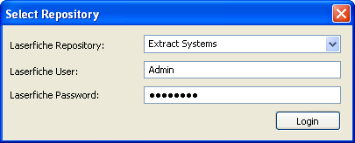
Figure 1

[If Administration console is launched without appropriate permissions]
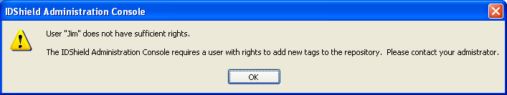
Figure 2

Repository Tab

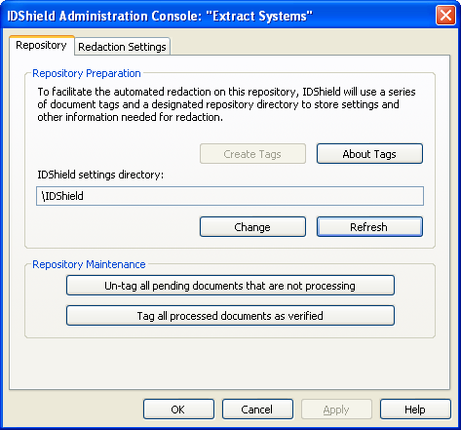
Figure 3

[Upon pressing “About Tags”]
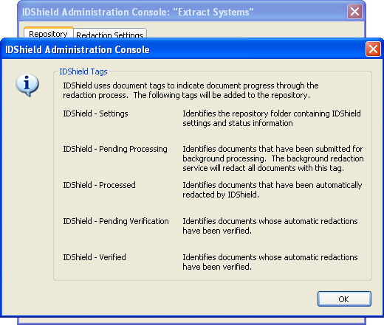
Figure 4

[Upon Pressing “Change Directory”]
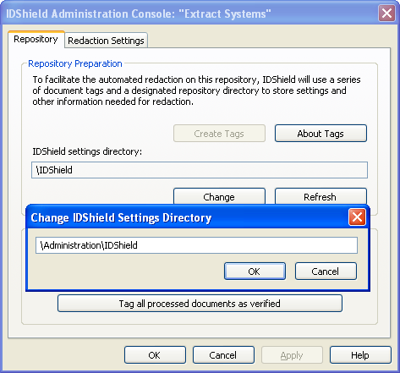
Figure 5

Redaction Settings Tab
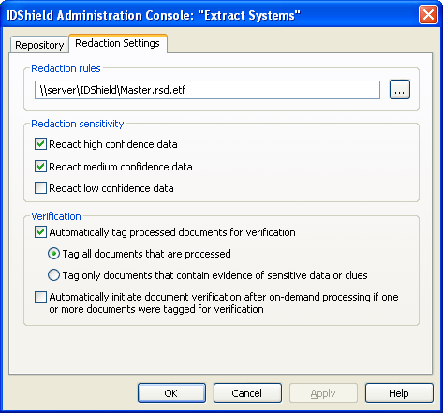
Figure 6

Background Redaction Service

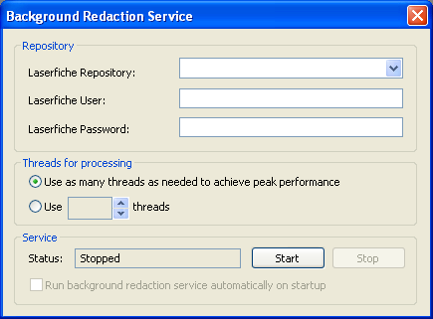
Figure 7

[If bad login info is entered and Start button pressed]
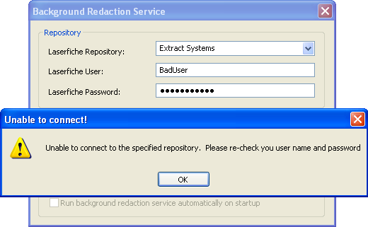
Figure 8

[After correct configuration. Same screen after closing & reopening the service app]
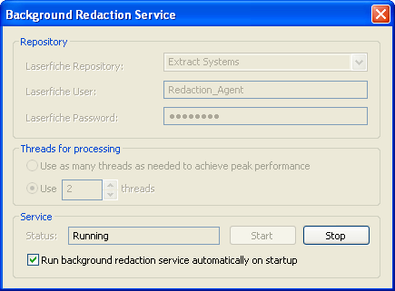
Figure 9

Laserfiche Client Integration
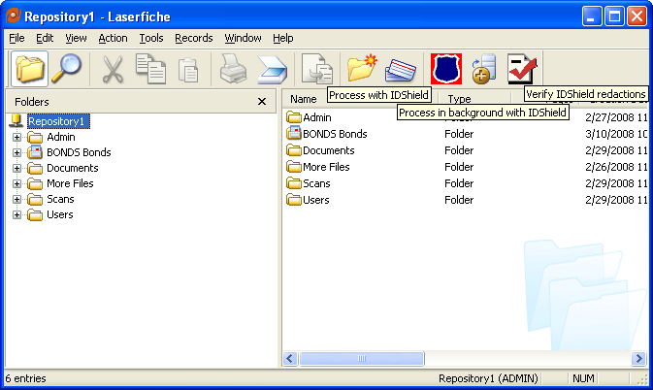
Figure 10

[If the buttons are used before the repository is prepared]
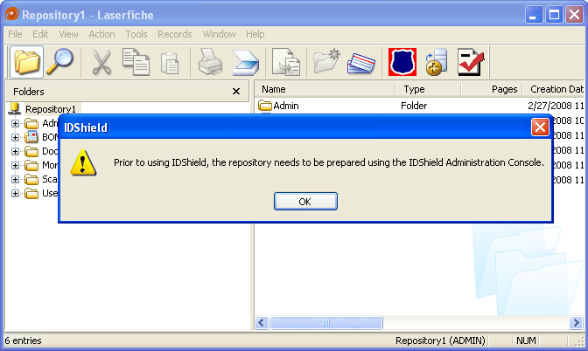
Figure 11

[Redaction or verification buttons pressed with large number of docs selected]

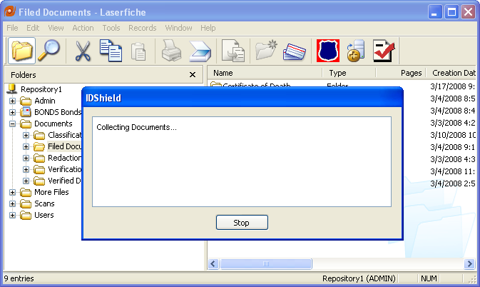
Figure 12

[Foreground or background redaction: some selected documents already processed]
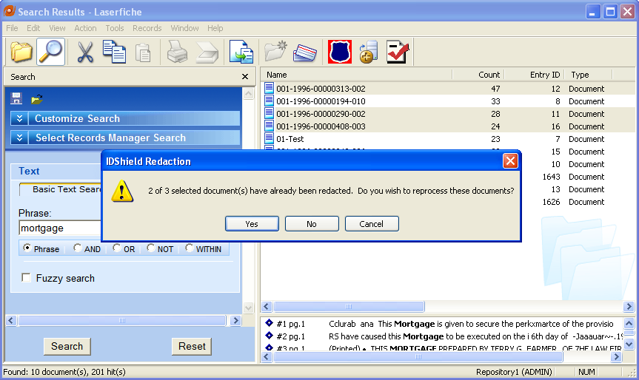
Figure 13

On-Demand Redaction progress
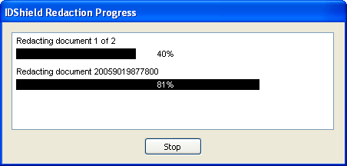
Figure 14

Background Redaction Submission

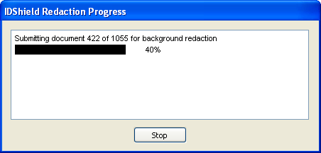
Figure 15

Document displayed for verification (with highlighted clues)
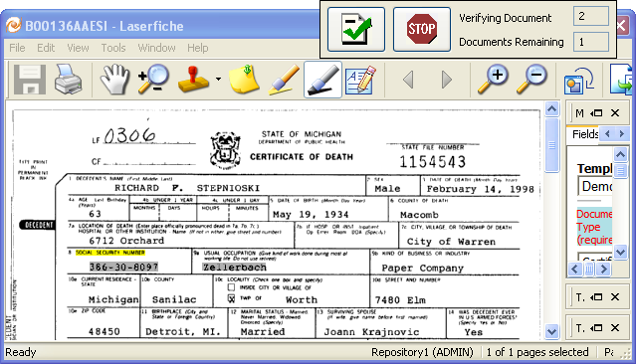
Figure 16

